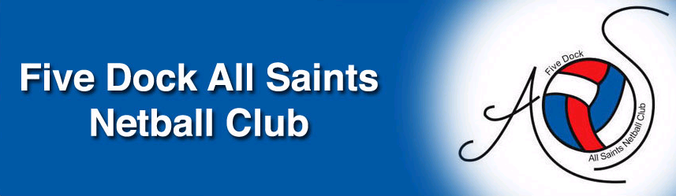
FDAS EXECUTIVE COMMITTEE NOMINATION FORM

2022 SEASON

I

of

wish to nominate for:

 President  MyNetball IT Administrator

 Registrar (Senior Teams)  Registrar (Junior Teams)

 Secretary  Assistant Secretary

 Treasurer  Assistant Treasurer

 Uniform & Equipment  Fundraising & Sponsorship

 Umpire Co-Ordinator  Assistant Umpire Co-Ordinator

 Development Officer  Coaching Co-Ordinator

 Assistant Coaching Co-Ordinator  Assistant Registrar

Mobile Number:
(May be / May not be published on FDAS website)

Preferred Email Address:

Please scan and send to: fdasncsec@bigpond.com

