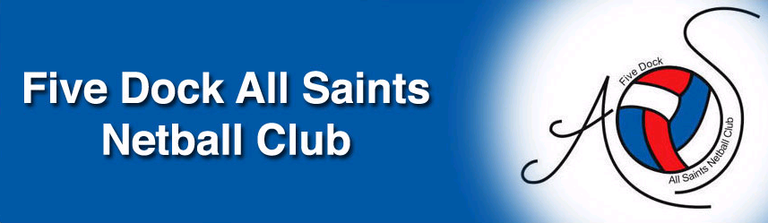
Dear FDAS Members
Some exciting news to share as Season 2020 approaches.
The FDAS website has received a revamp with a new look and easier to navigate menus and interface.
The 2020 Winter Netball Season Calendar has been released as follows:
Round 1 - Sat 28 March
Round 2 - Sat 4 April then extended break over Easter until
Round 3 - Sat 2 May
Round 11 - Sat 18 July - is the only round that is within school holiday periods
Grand Final day - Sat 29 August.
Good news on fees is that despite IWSNA raising their fees FDAS will have the same fee structure as 2019. In addition, ALL players will receive a FDAS training t-shirt as part of their membership fees.
2020 Registration OPENS online 1 Jan 2020. See our website for links and instructions.
Cintra Park is also receiving some much-needed upgrades to facilities which will be completed in time for the 2020 Season.
The FDAS 2019 AGM has been completed and your new Executive Committee is listed below. Please don’t hesitate to contact us if you have any queries and take note of the vacant Executive positions as we are always looking for new faces to join the best club in the IWSNA.
FDAS Committee 2020 |  | Contact Details
PRESIDENT | Darryl Stuart | darryl.stuart@hotmail.com
SECRETARY | Andrew Russell | fdasncsec@bigpond.com
ASSISTANT SECRETARY | VACANT
REGISTRAR - Senior Teams  13 Years and Above | Andrew Russell | amrussell@bigpond.com
REGISTRAR - Junior Team  Mini's to 12 years | Darryl Stuart | darryl.stuart@hotmail.com
ASSISTANT REGISTRAR - | Bruno Lorizio | bruno.lorizio@brother.com.au
MYNETBALL I.T. ADMINISTRATOR | Bruno Lorizio | bruno.lorizio@brother.com.au
TREASURER | Susie Baldacci | susanna.baldacci.17@gmail.com
ASSISTANT TREASURER | Lida Dal Cin | ldalcin@tpg.com.au
UMPIRE CO-ORDINATOR | Monique Coleman | aligator.ent@bigpond.com
ASSISTANT UMPIRE CO-ORDINATOR | Claudia Petrucco | cpet8852@gmail.com
COACHING CO-ORDINATOR | Georgie Arrow | contact.netball@gmail.com
FUNDRAISING & SPONSORSHIP | Patrick Everest | peverest@jmichel.com.au
DEVELOPMENT OFFICER | VACANT
UNIFORM & EQUIPMENT OFFICER | Jenny McLean | fdasuniform@gmail.com
ASSISTANT UNIFORM & EQUIPMENT OFFICER | Bruno Lorizio | bruno.lorizio@brother.com.au
GRADING COMMITTEE | Bruno Lorizio
GRADING COMMITTEE | Monique Coleman
GRADING COMMITTEE | Maria Stuart
GRADING COMMITTEE | Donna Antoniou
LIFE MEMBERS | Donna Antoniou
LIFE MEMBERS | Lida Dal Cin
LIFE MEMBERS | Mark Petrucco
LIFE MEMBERS | Darryl Stuart

Executive Positions Vacant:
Development Officer - Identifying and booking netball clinics for our players and coaches. Usually rebooking clinics we have used in the past as well as identifying new and exciting clinics for our members to attend.
Assistant Secretary - Responsible for booking and organising club events and executive meetings as well as assisting our Secretary in other areas of running the club as they arise which usually involves liaising with other Executive members to assist them with issues within the club.
For more information on how you can get involved with FDAS please contact us on the e-mail address below.

Regards
FDAS Netball club
fdasnc@bigpond.com

