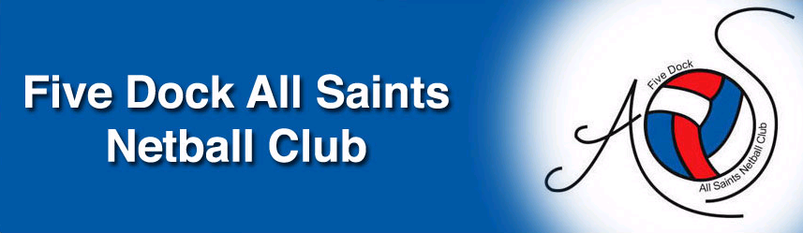

FIVE DOCK ALL SAINTS NETBALL CLUB
ANNUAL GENERAL MEETING
9 NOVEMBER 2021

ANNUAL REPORT
Incl EXECUTIVE COMMITTEE REPORTS

CONTENTS

Executive Committee | 4
Presidents Report | 5
Junior Teams Registrar’s Report | 5
Secretary’s Report | 6
Treasurer’s Report | 7
Senior Teams Registrar’s Report | 9
Fundraising Report | 10
Uniform and Equipment Officer’s Report | 11
Umpire Co-ordinator’s Report | 12

CLUB HISTORY

Our Club was formed in July 2005 from the amalgamation of the All Hallows and St Mark's netball clubs, and 2006 was our first year of competition at the Inner Western Suburbs Netball Association.

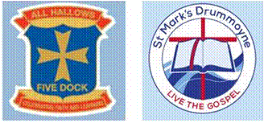

Although we are only young we are one of the largest junior clubs in the Inner Western Suburbs Netball Association. Our Club has enjoyed strong support from the communities at All Hallows Primary Catholic School and St Mark's Primary Catholic School to build a solid and united Club with players from Abbotsford, Five Dock and Drummoyne Public Schools as well as Domremy College, Rosebank College, Santa Sabina College and PLC.

Hall of Achievement – Honour Roll
2019 marked the Inaugural year of the FDAS Hall of Achievement
These Awards acknowledge the achievements of Teams, Coaches and Umpires – past & present.

2019

Teams
A4 Starlings (2017-19) Grand Final winners 3x years in a row
A3 Angels (2011-15) Grand Finals winners 4x years in a row
A3 Swans (2008-15) Grand Final winners 5x years in a row, Runners up 3x years

Coaches
Rachel Digiglio (2010-19) Starlings (3x Grand Final winners)
Robins (3x Grand Final winners)

Honourable Mention
Georgie Arrow (2019) 4x (of 4) teams made Grand Finals
Appointed NSW Men’s U23 Coach 2020

FDAS COMMITTEE 2021
PRESIDENT | Darryl Stuart
REGISTRAR - Senior Teams 13 Years to Above | Andrew Russell
REGISTRAR - Junior Team Mini's to 12 years | Darryl Stuart
ASSISTANT REGISTRAR - MYNETBALL I.T.  ADMINISTRATOR | Bruno Lorizio
SECRETARY | Andrew Russell
ASSISTANT SECRETARY

TREASURER | Susie Baldacci
ASSISTANT TREASURER | Lida Dal Cin
UMPIRE CO-ORDINATOR | Claudia Petrucco
UMPIRE CO-ORDINATOR | Monique Coleman
FUNDRAISING & SPONSORSHIP

COACHING CO-ORDINATOR | Georgie Arrow
DEVELOPMENT OFFICER/S

UNIFORM & EQUIPMENT OFFICER | Bruno Lorizio  Jenny McLean
GRADING COMMITTEE | Bruno Lorizio  Monique Coleman  Maria Stuart  Donna Antoniou
LIFE MEMBERS | Donna Antoniou  Lida Dal Cin  Mark Petrucco  Darryl Stuart

President & Registrar Junior Teams report
Season 2021 was a disaster with us going into lockdown half way through the season.

Inner West decided to award trophies to all teams running first and second in the competition after round 5.

We had some new Coaches and Managers join the Club this year, I must congratulate them all for giving up their valuable time to coach and manage their respective teams. By all accounts the girls had a rewarding and enjoyable short season of netball.

There were no Perpetual trophies awarded to the Premiers of any Division 1 teams due the lockdown and shortened season.

Hopefully 2022 will give us a full season of netball.

Last but not least I wish to thank the Executive Committee for their outstanding work during the season.

Darryl Stuart
President & Registrar Junior Teams
FDAS Netball Club

Secretary Report
2021 was another COVID affected season. The season started well and our club BBQ was a massive hit with everything sold out ahead of schedule. Then unfortunately the Winter Comp was cancelled half way through and Summer Comp cancelled altogether.
Gala Day didn’t proceed due to a combination of factors and presentation day was unfortunately cancelled again due to COVID.
FDAS continues to go from strength to strength due to the sacrifices and many hours committed by every member of the Executive committee. Our registered member base now regularly tops 400. The ultimate goal of our club is to provide a happy and safe environment for all of our members which I think we have achieved. It’s great to see such a large number of FDAS teams each Saturday at Cintra enjoying their netball.
Whilst success on court is not the main goal a happy team is often a successful team and this translated into the large number of FDAS teams being premiers and Runners-up.
In finishing I must say I am proud to be a part of such a wonderful club made the same by its members.
Andrew Russell
Secretary

Treasurer’s Report
FIVE DOCK ALL SAINTS NETBALL CLUB INC
Profit & Loss [Cash]
October 2020 through September 2021
 | Income
 | Grant - Community |  | $12,000.00
 | Fund Raising |  | $5,363.65
 | BBQ | $3,225.15
 | Cake Stall | $2,138.50
 | Registration Fee - Summer Comp |  | $150.00
 | Registration Fee - Winter Comp |  | $73,439.72
 | Mini Magpie 5-7 years | $1,440.00
 | Modified - 8-10 years | $11,390.00
 | Juniors 11-15 years | $34,170.00
 | Cadets 16-17 years | $10,340.00
 | Seniors 18 + years | $16,099.72
 | Active Kids Voucher |  | $10.00
 | Uniforms |  | $9,295.00
 | Dresses | $7,590.00
 | Jerseys | $1,320.00
 | Visors | $90.00
 | Caps | $90.00
 | Umpire Polos | $90.00
 | Shirts | $115.00
 | Total Income |  |  | $100,258.37
 | Cost of Sales |  |  | $0.00
 | Gross Profit |  |  | $100,258.37
 | Expenses
 | Bank charges |  | $30.53
 | Dues & Subscriptions |  | $48,586.90
 | Courses |  | $3,838.25
 | Clinics | $3,050.00
 | Coaching | $788.25
 | Court Hire/Lights |  | $5,262.50
 | Equipment |  | $2,300.00
 | Filing Fees |  | $72.21
 | Supplies |  | $3,503.50
 | Printing |  | $44.00
 | MyNetball Processing Fees |  | $1,134.43
 | Functions and entertainment |  | $1,778.00
 | Umpire & Runner |  | $8,000.00
 | Trophies/Awards |  | $5,745.06
 | Refunds |  | $3,155.00
 | Uniforms - refund | $275.00
 | Registration - refund | $2,880.00
 | Fundraising |  | $1,142.10
 | BBQ | $1,042.10
 | Gifts | $100.00
 | Uniforms |  | $7,293.00
 | Dresses | $6,435.00
 | Umpire polos | $858.00
 | Freight |  | $165.00
 | Total Expenses |  |  | $92,050.48
 | Operating Profit (Loss) |  |  | $8,207.89
 | Other Income
 | Interest Income |  | $13.03
 | Total Other Income |  |  | $13.03
 | Other Expenses |  |  | $0.00
 | Net Profit (Loss) |  |  | $8,220.92

FIVE DOCK ALL SAINTS NETBALL CLUB INC
Balance Sheet
As of 30 September 2021
 | Assets
 | Current Assets
 | Cash On Hand
 | Cheque Account | $16,764.31
 | Business Saver Acct | $66,583.20
 | Total Cash On Hand | . | $83,347.51
 | Total Current Assets |  |  | $83,347.51
 | Total Assets |  |  |  | $83,347.51
 | Liabilities
 | Net Assets |  |  |  | $83,347.51
 | Equity
 | Retained Earnings |  |  | $75,126.59
 | Current Year Surplus/Deficit |  |  | $8,220.92
 | Total Equity |  |  |  | $83,347.51

Registrar Report (Senior Teams 13 yrs - Senior)
In the Senior Registrar role I was responsible for the 13yrs teams through to and including the Seniors; a total of 24 teams comprised of 8 Senior teams, 5 Cadet teams and 11 teams from the 13’s to 15’s. Total number of players was up a little on the same team numbers as 2020.
The club has successfully made Wednesday at Cintra our official training night with most teams adopting that day. School training was not an option due to COVID all teams have made the transition to Cintra, with a small number on Mondays, Tuesdays and Thursdays.
Due to COVID the winter season was cancelled half way through with the IWSNA awarding Premiers and Runners-up based on one full round of each respective division. FDAS had 7 Premiers, 5 of those undefeated and 5 runners-up.
Premiers
B1 Raptors – undefeated, C1 Roosters – undefeated, Cadet 1 Harriers – undefeated, 14/1 Swifts,
14/4 Rubies, 13/1 Sea Eagles – undefeated, 10/2 Kookaburras - undefeated
Runners up
B5 Lorikeets, C2 Garnets, 15/1 Firebirds, 15/2 Phoenix, 14/1 Jets
Summer comp was also cancelled due to COVID.
I was also the 10yrs Grading Day co-ordinator and with assistance from the Grading Committee ( Maria and Monique ) as well as Darryl, Georgie and Bruno we graded 3 teams. The Div 2 FDAS Kookaburras who finished as premiers and the Div 4 FDAS Herons who finished fifth. The FDAS Eagles declined to be graded and were placed in Div 1 by the IWSNA, they finished fifth.
Due to COVID this year’s presentation day was again unfortunately cancelled. The club purchased trophies and gifts for our Premiers and Runners-up and these were distributed by Executive members to our teams to present at their individual end of season celebrations.
Thanks to Georgie Arrow for taking on the role of Minis Coordinator. With help week to week from some of our junior players Georgie is laying the foundations for our future netballers.
I would also like to thank all members of the executive for their support and hard work throughout the season without whom we wouldn’t have such a wonderful club.
Andrew Russell
Fundraising Report
FDAS did not have a fundraising officer this season. Pat Everest our previous office holder continued to liaise with Canada Bay Club and secured FDAS some funding even during extremely difficult times.
Prior to the season being cancelled FDAS conducted a very successful club BBQ and Cake stall.
Thanks Pat.
Financial summary of our Fundraising initiatives are as follows:

SOURCE / EVENT  Funds Raised $ | FY 2021 | FY 2020 | FY 2019 | FY 2018 | FY 2017 | FY 2016 | FY 2015 | FY 2014
Gala Day | 0 | 0 | (470) | *(510) | 3,265 | 4,656 | 3,674 | 6,395
Club BBQ & Cake Stall | 5,364 | 0 | 4845 | **3,776 | 4,408 | 4,504 | 3,796 | 3,520
Canada Bay Club community grant | 12,000 | 2,000 | 25,000  ^2,000 | 20,000 | 20,000 | 20,000 | 13,000 | 12,000
Jersey Sponsor | 0 | 0 | -- | -- | -- | -- | -- | 500
Trivia Night | 0 | 0 | -- | NA | 3547 | NA | 8,555 | NA
Specialist Photos | 0 | 0 | -- | -- | -- | -- | -- | 2,065
Barefoot Wine Promotion | 0 | 0 | -- | -- | -- | 55 | -- | --
TOTAL | 17,364 | 2,000 | 31,375 | 23,266 | 31,220 | 29,215 | 29,025 | 24,480
* Grant
^ Attendees Draw Prize in Oct 2019 for the Club Grants Launch but wasn’t deposited until November 2019

Uniform Officer’s Report
This year we stocked up on uniforms and are well stocked for the next season.
We fitted out several new teams from the junior’s cohort and several senior teams
As usual we supplied new match balls, training balls and fully kitted bags to all the new teams.
We continued to supply a FDAS training shirt to any newly registered players and coach’s shirts to new coaches and renewed umpires with new shirts.
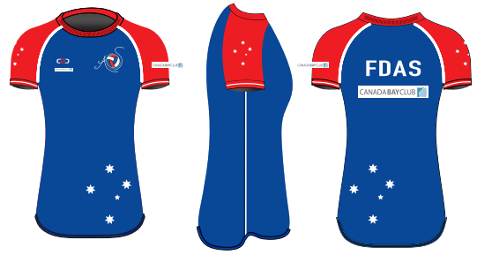
Most purchases for uniforms and visors were made online again this year which has reduced the cash handling issue, however, there were some minor issues with the reporting software. We still made the odd sale on Saturdays including visors, dresses and jerseys.
With Covid and distancing, all those that ordered uniforms came to my place for collection and in keeping with the safety measures, made appointments so that there was only one customer at the house at a time.
We purchased new patches in 2021. Some have been distributed and will continue to be used into next season.
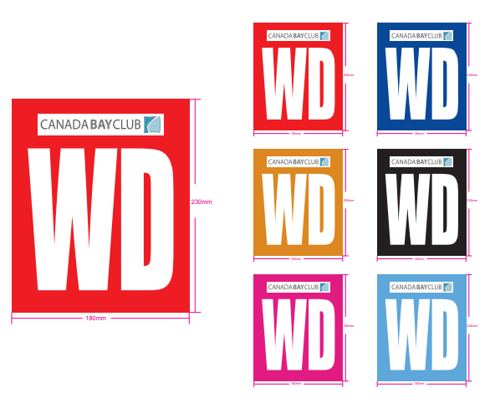
Stock take will take place and details of current stock will be forwarded to the treasurers.
We will need to review our club uniform and consider if we will align with the new strategies from Netball NSW that is encouraging inclusion and opening the sport to more players.
We look forward to a successful 2022 after what has been a most challenging 2 years.

Bruno and Jenny

Umpire Convenor Report
Umpire coordinator: Monique Coleman
Assistant umpire coordinator: Claudia Petrucco

The 2021 FDAS Umpiring team –
National B umpire –
- Monique Coleman
- Claudia Petrucco

National C umpires –
- Emma Petrucco
- Bruno Lorizio
- Rachel Digiglio
- Jessica Coleman
- Michelle Pelizzari
- Molly Eason
- Natasha Winton
- Holly Field
- Natasha Berry

Association badge umpires –
- Jemma Gilligan
- Lucy Garraway
- Samantha Berry
- Zoe Ransevycz
- Sienna Tierney

Although a very short 9-week season, FDAS were able to have the following umpires assessed for their Association level badge:

- Olivia Gilchrist
- Charlotte Hextell

We continued to provide as much coaching to our association level umpires, in the hope we can assess them for a National C, as well as to the unbadged girls hoping to be assessed for an Association badge. Unfortunately, due to the past 2 winter seasons being incredibly disruptive, we have not achieved our badging or coaching goals. We hope to pick this up in 2022.

The girls who are yet to be assessed include –
- Georgie Nalewabau
- Niamh Collins
- Lola Arnold

We would like to note that FDAS continues to provide support to other clubs in our Association with limited umpiring support. This season we assisted Lily and Maddy Stone from SHLNC to be assessed for their Association badge.

On behalf of Monique, we thank the committee for their support during 2 of the most challenging seasons of netball.

Thanks, Claudia

