The Registration links are:

MINIS, 8YRS AND 9 YRS

https://netball.resultsvault.com/common/pages/reg/welcome.aspx?type=6&entityid=42749&fl=1&id=35862

MINI MAGPIES choose Net – Activity/Skills

8yrs and 9yrs players choose Set – Skills / Competition

10YRS AND ABOVE

https://netball.resultsvault.com/common/pages/reg/welcome.aspx?type=1&entityid=42749&fl=1&id=35810

If your daughter is playing up a year, i.e playing in an age group above which she is eligible for you must register in the age group she is playing in not the one she is eligible for.

Please note:
Whilst FDAS attempts to accommodate most requests in terms of team placement, the executive from the club has the ultimate discretion in final team placement based on best fit and suitability. There will be no refunds given if the club finds a place for your daughter and you are dissatisfied with this placement.

For returning players or players who have been registered with Netball NSW

Click

Enter LOGIN ID and PASSWORD.
And proceed to Register

For players new to netball

Click
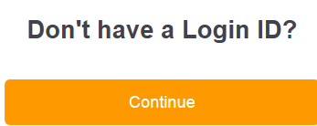

Enter details then click Search.

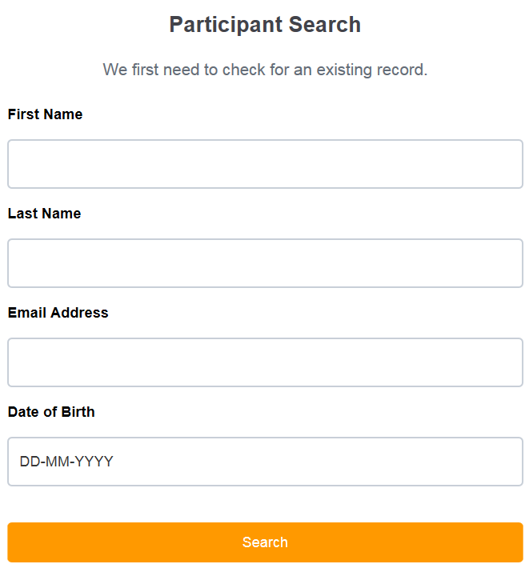

Assuming no record is found click Continue.

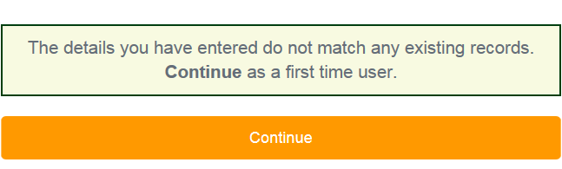

Follow system prompts to register and create a new LOGIN.

E-mail a copy of your birth certificate or passport and a photo immediately to

5yrs to 12yrs inclusive
darry.stuart@hotmail.com

13yrs and up
amrussell@bigpond.com
Your registration cannot be completed by FDAS without ID and a photo.

Technical enquiries:
Bruno Lorizio
bruno.lorizio@brother.com.au

